**COMP 66798-PROGRAM DESIGN METHOD.**

**Review Question Week 1 Session 1**

File :***nim_nama*_COMP6056_WEEK03.docx**

Your student Id: 2540118681

Your Name: Yonathan Handoyo

**Question :**

1. You require an algorithm to read in three values from a customer’s bank account: the account balance at the beginning of the month, a total of all withdrawals from the account for the month, and a total of all deposits into the account during the month. A federal tax charge of 1% is applied to all transactions made during the month. The program is to calculate the account balance at the end of the month by (1) subtracting the total withdrawals from the account balance at the beginning of the month, (2) adding the total deposits to this new balance, (3) calculating the federal tax (1% of total transactions – that is, total withdrawals + total deposits), and (4) subtracting this federal tax from the new balance. After these calculations, print the final end-of-month balance.

2. You require a program to read in the values from an employee’s timesheet, and calculate and print the weekly pay for that employee. The values read in are the total number of regular hours worked, the total overtime hours and the hourly wage rate. Weekly pay is calculated as payment for regular hours worked, plus payment for overtime hours worked. Payment for regular hours worked is calculated as (wage rate times regular hours worked); payment for overtime hours worked is calculated as (wage rate times overtime hours worked times 1.5).

**Answer :**

1. **Problem:**

**IPO Diagram → INPUT PROCESS OUTPUT**

|  |  |  |
| --- | --- | --- |
| **INPUT** | **PROCESS** | **OUTPUT** |
| Account balance beginning  Total Withdrawal  Total Deposit | * Subtract total withdrawals from account balance in the beginning * Adding total deposit into new bank balance * Calculate federal tax   (1%*(total withdrawal + total deposit))   * Subtracting federal tax from the new bank balance   (end month = newBalance – tax) | End of month bank balance |

**FLOW CHART:**

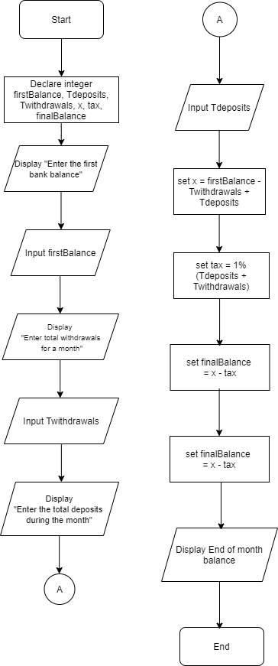

**Tdeposit** = Total deposit

**Twithdrawals**  = Total withdrawals

**X**  = firstBalance – Twithdrawals  
 + Tdeposits

**Tax**  = 1%*(total withdrawal   
 + total deposit)

**finalBalance** = X - tax

**Code**

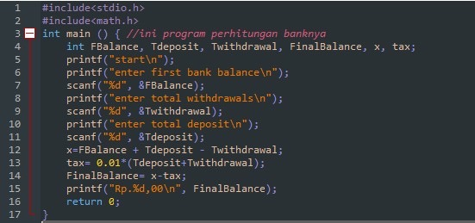

**Test Data**

|  |  |  |
| --- | --- | --- |
|  | Data set 1 | Data set 2 |
| FirstBalance | Rp 1.000.000 | Rp 2.500.000 |
| Tdeposit | Rp.500.000 | Rp 3.000.000 |
| Twithdrawals | Rp.400.000 | Rp.4.000.000 |
| X | Rp.1.100.000 | Rp.1.500.000 |
| tax | 1% | 1% |

|  |  |  |  |  |  |  |
| --- | --- | --- | --- | --- | --- | --- |
| Statement Number |  |  | Variables |  |  |  |
| Data set 1 | First Balance | Tdeposit | Twithdrawals | X | Tax | Final Balance |
| 7 | Rp 1.000.000 |  |  |  |  |  |
| 9 |  |  | Rp.400.000 |  |  |  |
| 10 |  | Rp.500.000 |  |  |  |  |
| 12 |  |  |  | Rp.1.100.000 |  |  |
| 13 |  |  |  |  | Rp. 9.000 |  |
| 15 |  |  |  |  |  | Displayed |
| Data set 2 |  |  |  |  |  |  |
| 7 | Rp 2.500.000 |  |  |  |  |  |
| 9 |  |  | Rp.4.000.000 |  |  |  |
| 10 |  | Rp 3.000.000 |  |  |  |  |
| 12 |  |  |  | Rp.1.500.000 |  |  |
| 13 |  |  |  |  | Rp. 70.000 |  |
| 15 |  |  |  |  |  | Displayed |

**2. IPO Diagram**

|  |  |  |
| --- | --- | --- |
| **INPUT** | **PROCESS** | **OUTPUT** |
| Reg hours  Overtime hours  Wages/hour | * Calculate total regular wages by multiplying reg hours and wages/hours   (reg hours * wages/hour)   * Calculate total overtime wages by multiplying overtime hours, and wages/hour, and 1.5   (overtime*wages/h*1.5)   * Calculate total wages by adding total overtime wages and total regular wages | Weekly wages |

**FLOW CHART:**

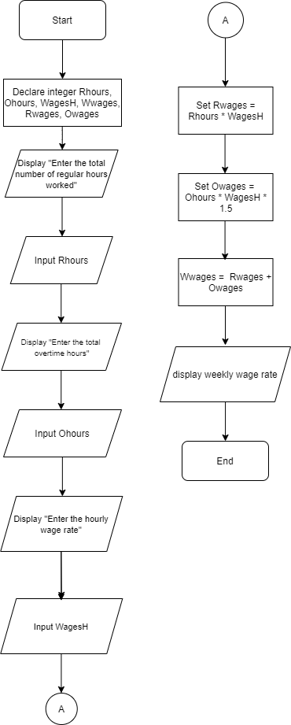

**Legend:**

Rhours = Regular Hours

Ohours = Overtime Hours

WagesH =Wages per hour

Wwages = Weekly wages

Rwages = Regular Wages

Owages = Overtime Wages

**Code**

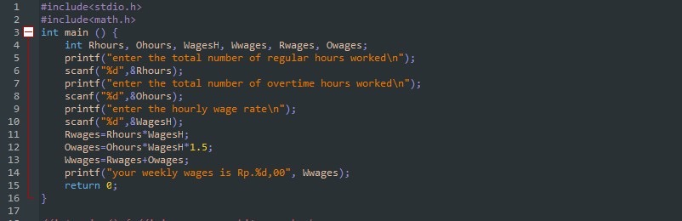

**Test Data**

|  |  |  |
| --- | --- | --- |
| Variables | Data set 1 | Data set 2 |
| Rhours | 40 | 25 |
| Ohours | 15 | 10 |
| WagesH | Rp. 50.000 | Rp. 40.000 |

|  |  |  |  |  |  |  |
| --- | --- | --- | --- | --- | --- | --- |
| Statement  Number |  |  | Variables |  |  |  |
| Data set 1 | Rhours | Ohours | WagesH | Rwages | Owages | Wwages |
| 6 | 40 |  |  |  |  |  |
| 8 |  | 15 |  |  |  |  |
| 10 |  |  | Rp. 50.000 |  |  |  |
| 11 |  |  |  | Rp. 2.000.000 |  |  |
| 12 |  |  |  |  | Rp. 1.125.000 |  |
| 14 |  |  |  |  |  | Displayed |
| Data set 2 |  |  |  |  |  |  |
| 6 | 25 |  |  |  |  |  |
| 8 |  | 10 |  |  |  |  |
| 10 |  |  | Rp.40.000 |  |  |  |
| 11 |  |  |  | Rp. 1.000.000 |  |  |
| 12 |  |  |  |  | Rp. 600.000 |  |
| 14 |  |  |  |  |  | Displayed |